THE VIKINGS
The Viking attacks beginning late in the Eighth century quickly earned them a reputation as fearsome, merciless and destructive
-common practice in early raids was to kill every man, woman, and child.
-many people believed that Viking attacks were God’s way of punishing the world.
-attacks ranged from England, to Spain to Italy in the Mediterranean to the Rivers of Russia and Constantinople.
-traveled by sea in “Longboats” or “Dragonboats”
-Fast, Light and efficient
-could easily travel down narrow waterways (fjords/rivers)
-Allowed Vikings the element of surprise attack and quick getaway.
-No one was safe – Europeans lived in fear.
-Some rulers began paying the Vikings to leave them alone
-usually payments consisted of taxes collected from already poor commoners.
-Few rulers able to effectively fend off the Vikings
-Charlemagne (Franks)
-Alfred the Great (Anglo-saxons)

Your Viking Name is...
Dufniall Leafslayer
Your Viking Personality: You might have a Norse name, but you really don't have what it takes to be a true Viking. Both your friends and your enemies think you're a little weird. You probably know which end of a sword to hold, but you're not a fearsome fighter by any stretch of the imagination.
You might grumble a bit at the lack of amenities on board a Viking longboat, but you can handle it. Vikings make fun of you all the time. Not always behind your back, either.
You have a fairly pragmatic attitude towards life, and tend not to expend effort in areas where it would be wasted. Due to your gregariousness, you don't strike fear into the hearts of your victims. Try to be a little more surly in the future.
VIKINGS HANDOUT & ASSIGNMENT
Your Name: _______________________________

WAAAAIT, For this assignment you will need a proper Viking Name. Use your mobile device and go to this website to sort it out. http://www.thequarter.org/Media/VikingName.php
Answer the questions HONESTLY

YOUR VIKING NAME: _____________________________________

Directions: Use the textbook and the Viking Handout to work your way through these questions.

Another name for the Vikings was the ________________________, largely because they came from the northern areas of Europe now known as __________________, ________________________ and ___________________.

List two geographical reasons that Vikings took to the sea instead of staying on land:
- __________________________________________
- __________________________________________

What is a fjord?
What Viking custom became a reason for young men to leave on “raiding expeditions?”

Viking longboats were much better than Saxon ______________________. The longboats were driven by ______________________ and a great square ________________. A wooden paddle was fixed to the ____________________ side.

The diagram below is already labelled, but please include an explanation of why the circled parts were critically important.
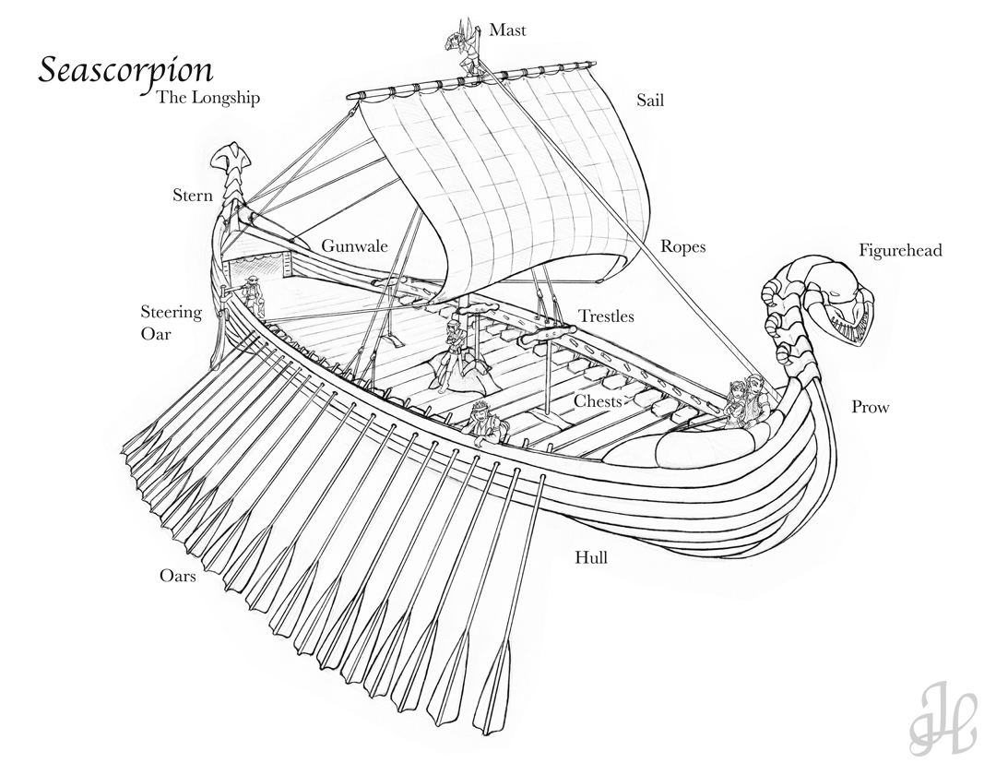
What was the name of the Viking who discovered Greenland?

The Vikings were fine ____________________ as well as sailors and shipbuilders. The greatest honor for a Viking warrior was a ___________________ at sea. A warrior’s death was believed to take a Viking home to ___________________ where he would join other Viking heroes and _________________.

In the following box, design and name your own Viking shield and weapon. (Colouring is optional.)

On the following page is a map of Northern Europe including Scandanavia, home of the Vikings. Using an atlas, your textbook, the handout and any other source material to label the following.

Countries:
DENMARK FRANCE
SWEDEN ENGLAND
NORWAY SPAIN
IRELAND GERMANY
SCOTLAND PORTUGAL
RUSSIA ICELAND
BELGIUM NETHERLANDS
FINLAND GREECE

Bodies of Water:
ATLANTIC OCEAN
BLACK SEA
MEDITERRANEAN SEA
As well, you will need to select a modern day city to “Raid” under your Viking identity. On your map you will need to label the city of your choosing, and draw the path you (the Viking) would take to get there. *Note, the city does not have to be on the coastline, but if inland, there must be a feasible by-sea route to take you to the city. In that case, you also need to clearly draw and label the river that would take you there.
COLOUR ALL LAND MASS NEATLY
VIKING LANDS SHOULD BE COLOURED DIFFERENTLY FROM THE REST OF THE LAND MASS.
LABELS SHOULD BE CLEAR, NEAT AND EASY TO READ.
INCLUDE 2-3 SENTENCE EXPLANATION OF WHICH CITY AND WHY IT IS YOUR TARGET (Geographical or other reasons).

